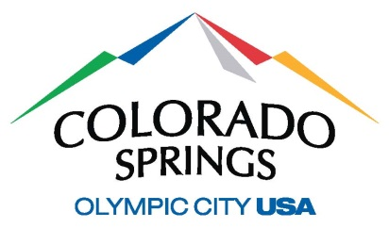
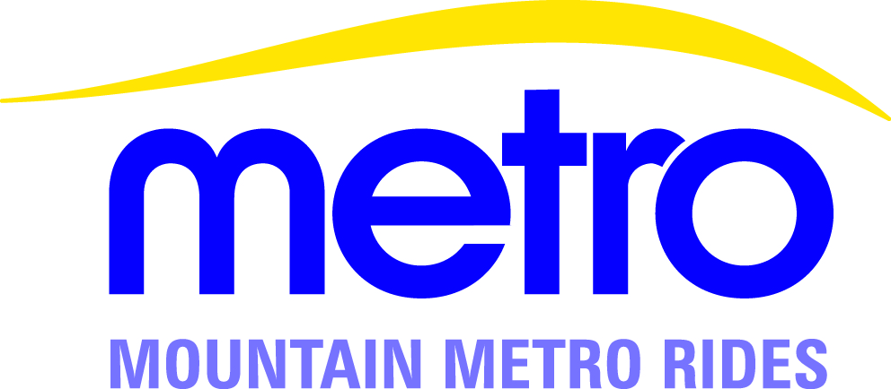

Mountain Metro Rides Car Wash

The driver must bring the van to any of the following Colorado Springs Water Works Car Wash locations for a full-service car wash, no more than once every two weeks:

- 525 South Nevada Nevada Avenue and Moreno Avenue
- 1108 North Academy North Academy Boulevard and Galley Road
- 2253 La Montana Way North Academy Boulevard and Montebello Square Drive

Notify the attendant you are with Mountain Metro Rides and give them the van number, the license plate number and print your name on the sales slip. Water Works will bill MMR monthly for car washes and MMR will submit payment to Water Works directly.

MMR will not reimburse car wash services made at any other establishment.

