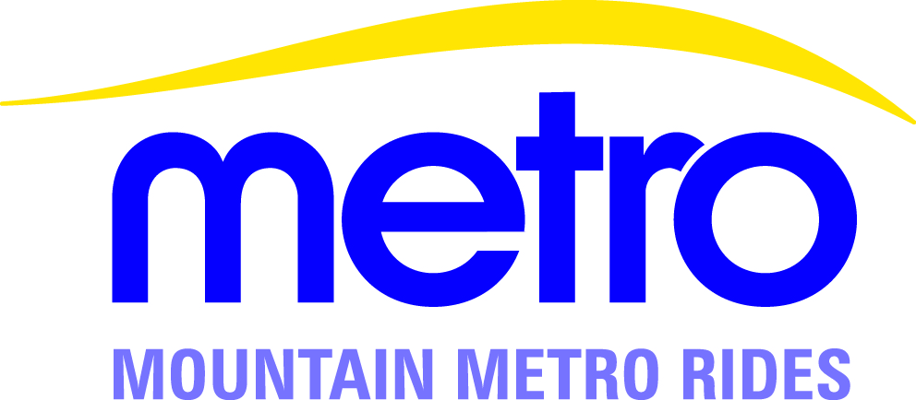
Mountain Metro Rides Fueling Locations

Vanpool vans must be fueled with unleaded fuel only, at one of the following City Fleet locations. You may be required to check-in with the guard after hours or when the gate is closed.

- City Fleet Complex (Fontanero & I-25)
404 West Fontanero Street (Open 24 hours)
Driver must call 668-7867 to enter and exit the facility

- Pinkerton Service Center (Powers & Woodmen, near School District 20 bus barn)
7710 Duryea Drive (Call ahead after 6pm: (719) 668-7867)

- Leon Young Service Center (Hancock Expressway, south of Fountain Boulevard)
1521 Hancock Expressway (Call ahead after 6pm: (719) 668-7867)

- Colorado Springs Utilities East Service Center (Circle Drive & Willamette Place, behind Fargo’s Pizza Palace)
2910 E. Willamette Place (Open 24 hours)

- Transit Campus (Hancock Expressway, south of Fountain Boulevard)
1165 Transit Drive (When the gate is closed, use Leon Young Service Center)

Each van is equipped with a fuel sensor that tracks the number of gallons disbursed; therefore, a receipt will not be issued, and no further documentation is required from the driver. Contact MMR staff immediately, if there is a problem with the fuel sensor.

MMR will not reimburse fueling expenses from any other establishment.

